Artistic Robot
- An EPS@ISEP 2016 project
Adam Dziomdziora, Mikko Mänysalo, Nona Pattiselano, Fraser Robertson, Daniel Nicolae Sin

Abstract—The team, Primeira EPS Tribo, undertook the project of designing and constructing a robot which creates drawings solely based on the voice input from the user. The project’s goal is to introduce a new generation, especially girls, to the world of engineering as, in the past, it has proven difficult to achieve this. To combat this, the team created the Graphbot using computer software to design and simulate the product before creating a prototype to ensure that the final design of the Graphbot would be fully functioning and safe for the customer to use.
Keywords—Engineering Education, Collaborative Learning, European Project Semester, Robotics, Art.

Introduction
The task is to design, develop and build a robot that creates art. The team decided to build a drawing robot commanded by voice for children. The robot should be able to change the pen it is using in order to be able to draw in different colors. The robot has to go forward, backward and change the direction. The area of drawing is limited to the paper. The robot is intended for children to introduce them in technology from an early age. The main goal of the Graphbot is to introduce girls to technology from an early age. This could inspire them to get into technology and later study in a STEM-field. Besides this use the robot should be a creative tool to express yourself. Both girls and boys could use the Graphbot. People who are limited in their movement could also use our Graphbot to create art. It will also be possible to upload different code or modify the existing code of the Graphbot. The development of this robot is an opportunity to learn more about robotics and programming. The team already has some limited experience with Arduino, but has never touched upon a project of this size. As future engineers this project is very interesting as robotics is an up and coming market. The specific skills acquired in our different studies comply with this project. The development of a drawing robot while regarding marketing, project management, sustainability and ethics still remains a challenge. It is never easy to work in a team. This team consists of people with different cultural and study backgrounds, making it even harder. This is however also an advantage. The team has the chance to learn a lot from each other and by sharing their knowledge work towards a common goal: bringing this project to a good end.
This project is part of EPS@ISEP2016. European Project Semester [1] is a program that brings students together from all over Europe. The program was designed for engineering students, but others can participate as well. The students are divided in small groups from 3 to 6 students preferably from different countries and with another study field. Every group is given a different project to work on during one semester. There are classes that support the project and help to develop it. These topics of these classes at ISEP are: marketing, sustainability, ethics, project management, communication and an Arduino crash course. The students are supported by the EPS-team which consists of teachers from various study fields.
We were given certain requirements that our robot should fulfill by the EPS-team.
The robot should:
- Move on a plane
- Work with distinct colors
- Be aesthetically pleasing
- Allow changing the drawing paper
- Have as maximum dimensions 1.00 × 1.00 × 0.80 m
- Reuse materials if they are provided
- Use low cost hardware solutions
- Use open source software
- Comply with the Machine (2006/42/CE 2006-05- 17), Electromagnetic Compatibility
(2004/108/EC 2004-12-15), Low Voltage (2014/35/EU 2016-04-20), Radio Equipment (2014/53/EU 2014-04-16) and Restriction of the use of certain Hazardous Substances(ROHS) EU Directives.

State of the Art
This chapter shows the work that we did as a group when researching products already on the market which could be similar to our own final design and ultimately selecting the path that we thought would be most beneficial to us and the customer. We researched the existing products in this market and compared them. In the conclusion the choices that were made regarding our project are described.
A drawing robot is a machine that can draw. In our project we will use a pen or marker to create art. In other robots you can also find the use of paint. The robot should be able to hold a pen and move it over a surface. The input could be given by various actuators. It could be by an existing drawing, a picture or a person controlling it. In some cases, the robot draws on its own.

Existing products
When researching existing types of drawing robots, we discovered that there are many of these types of devices already on the market, which are being used by artists, companies and by the public and are intended for people interested in robots or the arts.
One of the most commonly used products of this kind that is used mainly in manufacturing processes and some arts is the robotic arm [2]. Probably the first method which comes to mind would be that of the robotic arm which, if constructed correctly, can perform drawing tasks smoothly and precisely. It would be simple to construct and be aesthetically pleasing. Materials can be expensive. Movement of the arm can be sudden. The arm can only reach a certain radius when in use.
Another form of robotic art which is commonly used in society is the drawing robot which travels on wheels. This consists of a robot with 2 wheels and the pen attached at the front so that the device is stable and can travel around the paper freely but has no particular precision when drawing. It can operate over a large area on a flat surface and also would not be expensive to buy the parts. The base is simple to build and the Arduino board would be easy to program and it also can move freely around a plane. It can be less precise when in use and changing the color of the pen could prove to be difficult.
An uncontrollable method of drawing on paper using a robot is that of a vibrating robot [3]. These gadgets are used by some but not particularly by artists as they have virtually no control over what is being drawn. It could be easy to make and relatively cheap although the vibration causes it to be unable to continue is a single direction steadily.
One of the less well known methods of robotic art is the Egg- Bot. Although this product is not used for writing on paper on a flat surface, it allows the user to draw on objects that are almost impossible to accurately draw on. This method allows the user to be able to print on difficult surfaces. The structure of the device allows the painting of Easter eggs to be carried out easily. This type of drawing machine can only draw on a limited number of objects
A method that we carefully considered for our project was the spider robot which had four poles, one in each corner of the table or work surface, and string attached to each which all were attached to a pen or marker in the center of the paper. This type of of drawing robot was considered as it would be relatively easy to construct with four motors controlling
the length of the strings. The pen would be controlled by the string attached to each corner either lengthening or shortening depending on where the user would want the pen to be on the paper. The spider device can cover a vast area of a plane if long enough strings are used. This method can be used on a horizontal or vertical plane. Drawing in the corners of the page could prove difficult. If a four string system is used then it would be hard to calculate the length that some strings would need to contract or expand.
The last type of robotic art form we looked at was the printer robot [4]. Basically, this type acts in the same way as a computer printer but would allow the user to print on any type of surface.
Another choice we had to make was the type of input we would use to command the robot to perform certain tasks. There are many ways in which humans can interact with robots, but we researched four of the most popular and easily usable command methods for our project. The printer drawing robot can provide a good level of precision.
The drawing time will be decreased if many of the same drawings are to be printed. The construction of this robot would be very complex. The cost of the materials could be increased as at least 3 motors would need to be purchased. The programming would be extremely challenging.
The method of communication that we will use is sound. Whether it be words, tones or decibel levels, sound is the easiest way to communicate as we can easily express what are we attempting to say so that other humans or robots can understand and respond in the correct manner. When the use of sound cannot be used effectively, gestures can be used to communicate between humans and robots if a camera is linked to the robot. This means that the camera can recognize certain gestures performed by a human and pass the information onto the robot to perform the tasks already set in the programming stage. A camera which is attached to the robot can also be used to recognize colors that are placed in front of it. The different colors of paper, cardboard etc. can be used to signal a different command which will be carried out by the robot. The last method of interacting with the robot that we investigated was the smartphone application. This is probably the most up-to-date method of communication as smartphones have only became reasonably priced for the public for around 5 years or so. The application would show several buttons on the screen with commands for the robot to perform which the user would only have to select.

Comparison
Once we had researched all available possibilities which appealed to the group in terms of the structure of the robotic drawing device and the type of input that would be used to command the robot, we could then compare them against each other in terms of advantages, disadvantages, the parts used for construction and the cost of the materials. These construction and input methods appealed to all of us as they instantly took our interest, they were aesthetically pleasing stationery and when in motion, they were challenging so we could gain a sense of satisfaction when completing the project and they all would provide a good service to our customers. Table 1 was created to collect all of this information for an easy comparison on all subjects.

Conclusion
After comparing these sets of methods of construction of the drawing robot and the way in which it receives a command, a final decision could be made on what direction the project would be heading in. The robot structure that the team decided on using was the wheels method in which the device can move around on a plane on wheels with a pen attached to the front of the device. We decided this was the best solution for the task as the device can draw over a large area on a plane. The base of the robot would be easy to build and relatively cheap to buy the parts for with the correct components. The programming of the robot would be easier than that of the other options and with the wheels, the device can move freely around the paper. The materials for the whole robot would be within our budget as well which may not have been the case for other options.
We also decided that sound would be the best option for the input to command the robot. This is the best option as it can be used by people of all ages and fun can be had when using the system to create drawings. Also, if we allow the user to create their own commands for the robot then this can add to the feeling that they have created something special.

Proposed Solution
The team started by adding some requirements to have a better view on what should be achieved by the Graphbot. The robot has to be able to recognize simple voice commands and respond accordingly in a timely manner. The Graphbot should be user-friendly and childproof. It has to be easy and clear how one must use the robot. The drawing area should be detected automatically, ensuring the robot does not draw on the floor or table. The user should be able to change the drawing color with ease. The connection to the Arduino should be accessible for the user. This way there is an option to change the code and even upload drawings for more advanced use. After setting clear requirements and making the decision to work with a configuration based on wheels the team could move forward and start solving the various issues. These issues are: how to change the drawing color, how to attach the components, choosing the right components, how to balance the robot, how to connect the electronical components, how to write the code. These tasks were divided among group members.
Before depicting the proposed solution, the reader can find a discussion about the various topics related to the classes received during the European Project Semester and how they affected our work. The classes discussed here are: Project management, marketing, sustainability and ethics.
- Project Management
Project Management is one of the main aspects needed to realize a project. It is an important tool, which enables the team members or the project manager to:
- measure the risks of a project
- analyze responsibilities of the people involved
- monitor the cost and the budget
- create the product requirements
- manage the duration and deadlines of the individual tasks
Most importantly, project management allows all of the people involved in the project to follow the daily schedule and monitor the deadlines. Thanks to the use of tools such as “Microsoft Project 2016” or a Gantt Chart, the team was able to assign each task to a team member, set the proper deadlines and expected duration for each task and deliverable, and follow the completeness of this project. In addition, communication turned out to be an important role in project development. In the very beginning the team decided to arrange all meetings through social media or mobile contact. Thereby, when one of the team member reached a problem with his part of the project, he or she could immediately obtain the appropriate help and feedback from others. This way, the team was able to be up to date with all the tasks and organize theirs work well.
- Marketing
The marketing group for the Graphbot are children between the ages of 5-12. The product has been advertised to be more attractive to girls. With this approach the idea is to get females interested in robotics and engineering. The reason behind this would be that engineering and technology in general is male dominant. It is an edge for children to get interested in technology at an early age. When learning starts early they will have a good understanding of technology as an adult. By having fun and getting creative with the Graphbot, children will hopefully learn and have fun at the same time. The Graphbot is a toy that can create art through voice command recognition so there are no other products like ours on the market right now and we are filling a gap in the market. The Graphbot is a somewhat affordable and interesting toy for children.
- Sustainability
Sustainability is a concept which presents three aspects regarding to the avoidance of any issues in technology and the production process. Implementing sustainability measures gives the team a greater understanding of activities to create the prototype. The main issues of sustainability in the project are the use of low cost materials in small quantities and to choose the best solutions of components to achieve the prototype, which is very important. Using recyclable materials like glass, rubber and plastic or wood and to implement a Life Cycle Analysis are essential to make the product as sustainable as possible. The environmental aspect is important as well for Eco- Efficiency Measures because it is using electrical energy and it is important to think about how to reduce energy usage to increase our product’s energy efficiency. The economical aspect includes the task of using resources and money in an efficient manner [5]. Economical labels give information on economic impacts of this product. The target of this aspect is to teach how it should identify the issues and to analyse them in a critical way. The social aspect is also necessary to take in consideration because it should meet the customer needs and the goals of this project is to achieve a functioning product. The customers’ opinions are useful to help develop this prototype because their feedback can increase or decrease the number of customers satisfied by the product and help the team alter the product to suit the needs of the customers. To cover all issues of sustainability, the team must implement a Life Cycle Analysis model [6] to analyse the whole product from the design stage until recycling. Life Cycle Analysis is divided into these subjects:
- Design process
- Manufacturing and assembly
- Packaging
- Use the product
- End of life
- Ethics
The main areas that the team considered throughout the process in terms of ethical and deontological concerns are:

- Engineering ethics
- Sales and Marketing ethics
- Academic ethics
- Environmental ethics
- Liability
Engineering ethics is arguably the most relative to the project as it deals with the health and safety aspect in relation to the members of the team, others involved in the project and the general public [7]. It also takes into consideration that people working on the project must carry out tasks to the best of their ability in fields only in which they are qualified. Sales and marketing ethics includes the research of products which are already on the market and the research of potential customers in an ethical manner. Pricing and the relations between the products competitors is also important to help ensure that the team created a trustworthy and attractive product for the customers. The promotion of the product was also carried out in an honest manner with no misleading statements. During the process of the project, the utmost care was taken when selecting products and materials to ensure that they were sustainable with no hazardous substances within them. Liability takes into account the various directives which are in place to help create a product which is legal to place on the market and safe to use.

- Our Solution
Figure 1 is describing the main functions of the robot. The power supply (red/full line) is connected to every other component. They all need power in order to work. The sensors input (green/dots) is connected to the micro controller. In the micro controller the data from the different input sensors is processed. The result of this data is translated to commands for the output (blue/stripes). So for example if someone says ‘forward’ the sound sensor will pick this up. It will send a signal to the micro controller. This signal will be translated and the micro controller will signal both motor wheel 1 and motor wheel 2 to start working. A more detailed version of the electronic schematics can be found in the enclosure.
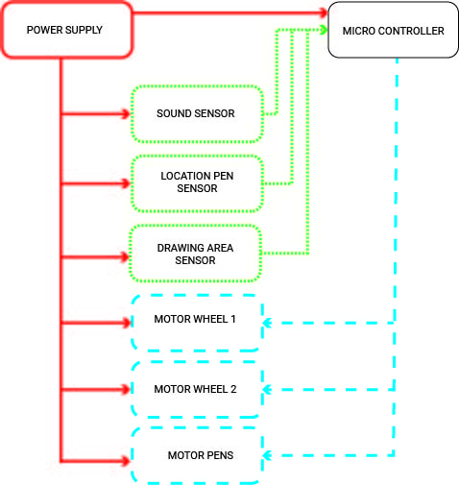
- Blackbox schematics
The proposed solution involves finding a good manner to place electronic components into the robot. The chosen components are: Arduino Uno R3, an EasyVR shield [8] for recognition of the voice, a stepper motor for changing the color, two DC motors to move the robot, the driver L293D to control these motors, polymer lithium battery, an infrared sensor to detect the drawing area, a microphone and speaker, an on/off switch and the protoboard to connect all wires. In figure 2 it explained how the components are placed in the Graphbot. The PCB will be attached to the upper part of the casing. On this the microphone and speaker will be placed as well as the needed resistors and cables to connect everything. The 5 V stepper motor is used to control the color change of the pens in the Graphbot as it allows the pen wheel to rotate by a specific angle. The driver L293D that the stepper motor is connected to be used to control the stepper motor and the both of the DC motors as well which control the wheels which they are at the sides. In the case that the Graphbot reaches the edge of the paper, the IR sensor placed on the bottom in the front of robot to detect the edge paper and give a signal to the motors to tell them to stop or reverse. The microphone that is located above the stepper motor is used for the input to the system from the user and for feedback it is using a speaker to tell to user if the voice is recognized. The microphone and the speaker are connected to EasyVR shield. All of these components are connected to the driver shield which is placed on top the Arduino Uno. This driver can then be connected to a PC to allow the programming of the components to carry out specific tasks within the Graphbot. The Polymer Lithium Ion Battery is being used as it allows to power all of the components that are being used when they are needed. The battery is placed in the center of the robot and is accessible for charging through the bottom. The DC jack is used to connect the Arduino to the battery. A caster ball is placed underneath the rear of the robot for extra support.
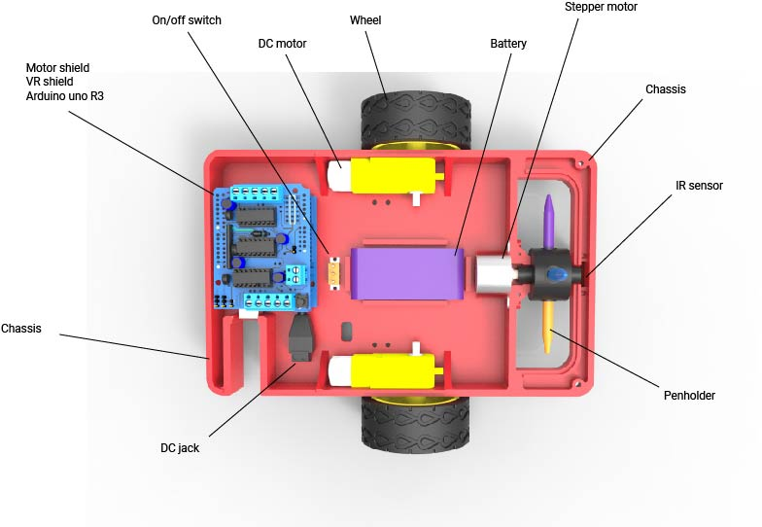
- Part of the components placed inside of the drawing robot
The best choice to cover the chassis is a plastic casing. In this project the material that will be used is plastic because it can be easily molded, it has a high durability, it is recyclable and the access to a 3D printer enables the team to create any shape that might be necessary. That is why the team has decided to use plastic as a material. Later in the production phase the chassis can be realized through injection molding.
To ensure the right amount of pressure while drawing there is a spring attached to the penholder. This will push the pen against the paper. This wheel with pens on is connected to the stepper motor. The motor which has been chosen has a flattened shaft and this fits into the wheel, as shown in Figure 3.
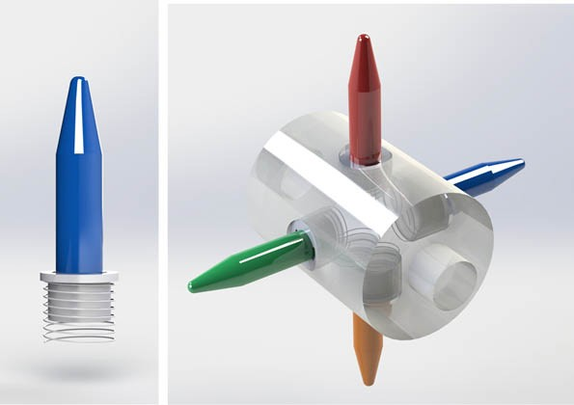
- Pen changing mechanism design 3D model
To secure the different colors to the wheel there is a turning mechanism in the penholder, as shown in Figure 4.
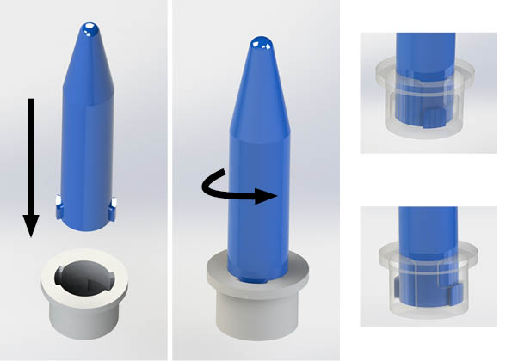
- Single pen design 3D model

Discussion
In this paragraph the reader can find the different opinions on the EPS-project.

Author 1
The European Project Semester at ISEP was a great life experience for me, I very much enjoyed working on and developing the Graphbot with my teammates from all over Europe. As I was working in a team in which everyone has studied different subjects, I could learn from them when working on some parts of the project in which I was less experienced.

Author 2
The European Project Semester has been very good practice on engineering and project work in general. Working as a group on a problem for a full semester is a good way to learn important skills that are needed in the future. I have done a lot of different group work before but never anything like what the EPS has to offer. Working a practical project in a multinational group is a great experience for anyone.

Author 3
For me participating in an EPS and Erasmus exchange was one of the greatest experiences in my life. The most important thing is that I learned how to live on my own, how to communicate and live with different people, going beyond the language and culture boundaries. Participating in an EPS is really great preparation to start your own company and shock the world with a breathtaking innovative solution. Thanks to teams consisted of people from different skills and coming from all over the world together we were able to make our dreams come true and prepare working prototype. Here we learn how important cooperation is, that acting alone you cannot achieve the same success as a team! Putting your trust in a team member does not only allow you to work properly but creates friendships, which may even last after EPS is ended. Facing problems and difficulties during project development was an opportunity to learn how to invent solutions ad-hock for unexpected situations. Being an engineer is being able to think out a solution for new problem, and this is exactly what EPS teaches you.

Author 4
EPS is a very good way to learn how to work independently as a team. The experience teaches one that people have very different views on how to work as a team. It is not easy to cooperate smoothly. There are always struggles in a team. I believe there are even more struggles in an EPS-team. It is a challenge to overcome all these extra differences. There is support from the teachers but a lot of problems have to be sorted out by the team alone. It is hard to anticipate the knowledge and capabilities of the other team members. This often lead to misunderstandings. The EPS program has thought me a lot about teamwork and has given me an insight in different cultures and in other study fields.

Author 5
To join the EPS Program has been a good experience. I never did anything like it before. To work with different people from different countries and culture is wonderful. I only met eager students who enjoyed this project with me. I am glad that I am a part of the best team I have ever worked with. Together we have made some good memories during this project. I visited beautiful places here in Portugal with wonderful views and I recommend everyone to come here and join this program. I learned how cooperation is essential and how important it is to work as a team. Five people from different countries in one team can realize extraordinary things. I learned that it is important to find a good solution as soon as possible to pass over any issues. In conclusion to join in this Project and Erasmus you do not have anything to lose.

TESTS AND EXPECTED RESULTS
Regarding the main functions of the robot, the most important test was Voice Recognition. The team firstly connected the speaker to make sure that it worked properly, then the team attempted to play various sounds through the speaker to prove that the speaker was fully functioning. The next step was to use the preprogrammed voice command ‘robot’ to make sure that the robot could recognize the sound input. The EasyVR has been programmed to recognize these five commands: “FORWARD, DOWN, LEFT, RIGHT, CHANGE, STOP”. After that one of the team members has been speaking to the shield and it worked successfully with the speaker giving positive feedback. After that, the next stage was the Motor Shield testing. The team has achieved to control the 2 DC motors and the stepper motor in the way that was expected which was the wheels that are connected to the DC motor were rotating while the stepper motor was able to rotate at a specific angle. The next step was combining voice commands with enabling particular motors, the team encountered a problem at the start when the current from the USB was too low but the team attached an external power supply which allowed the system to function. Then the team tested the IR sensor itself and it worked correctly. When a white sheet of paper was close to the sensor, the value given was around 40 while the value given when close to a black surface was almost 1000. Thanks to this the robot is able to detect the edge of the paper when in use. Another difficulty that the team faced was when testing the IR sensor with the robot, the cable from the IR sensor to the Arduino lost connection and when reconnected the Arduino would not function correctly. To try to overcome this problem, the team attempted to upload the new bootloader and change the faulty processor in the Arduino but this proved unsuccessful. The first steps to making the prototype can be seen in figure 5.
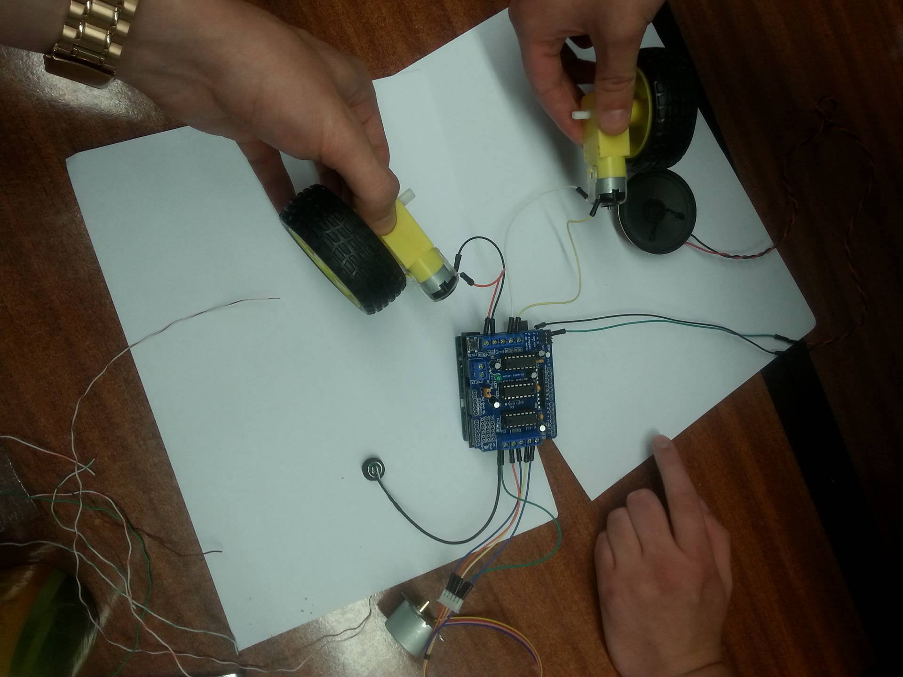
- Prototype in progress
The prototype is not yet finished but as soon as it is some tests have to be completed. First the robot has to be able to be turned on/off by using the switch so this has to be tested. Most likely problem in this would be false connections. When the robot turns on and off properly, the drawing can begin. The team must test that the robot responds to the right voice commands and acts properly. The commands are Go, Left, Right, Back, Stop and Change. All the commands are for movement except ‘’change’’ and that is designed for the color change. One major test is for the infrared sensor (IR sensor) and if it detects the surface as it is supposed to. The infrared sensor should detect the edge of the drawing surface and stop the robot before it moves outside of the area.

Conclusion
To summarize, the Graphbot has been presented regarding technical details, including its design, main functionalities, and the results of initial tests. Considering the fact that the project is still under the development phase, the final product has not been finished yet. However, the voice recognition unit, motor control and IR sensor have been tested and resulted in positive output. Nevertheless, before delivering to the final users a long-term period test must still be done, in order to detect further issues. Taking the actual finished and working prototype into consideration, there still are windows of opportunities for further improvements. For example, a solar system power source could be implemented, as well as innovative drawing techniques and last but not least, customer demands and needs. Furthermore, new version of the Graphbot could be invented, using gesture control.

Acknowlegedgements
Special thanks to Paulo Ferreira for trying to reanimate our Arduino.

References
- Jørgen Hansen - Copenhagen, Denmark, and Duane Abata - U.S. Coordinator at SDSMT, U.S.A “Introduction”
http://europeanprojectsemester.eu/info/Introduction [Accessed in May 2016]
- Makeblock company, “mDrawbot Kit”
http://www.makeblock.cc/mdrawbot-kit/ [Accessed in March 2016]
- Instructables, “Drunken drawing robot”
http://www.instructables.com/id/Drunken-drawing-robot-/ [Accessed in March 2016]
- Wuhan HAE Technology, “YC-S25OP State-of-the-art Technology Wall Printer For Individuality Home Decoration”
http://www.chinahae.com/product_yc-s25op-state-of-the-art-technology-wall-printer-for-individuality-home-decoration_13988.html [Accessed in March 2016]
- Daly, H.E. (1990). “​Toward some operational principles of sustainable development”​. Ecological Economics 2: 1–6.doi:​10.1016/​0921-8009(90)90010-r. [Accessed in April 2016]
- ISO 14040.2 Draft: Life Cycle Assessment - Principles and Guidelines [Accessed in April 2016]
- N. S. P. E, “Code of Ethics,” Code of Ethics, Jul-2007. [Online]. Available at: http://www.nspe.org/resources/ethics/code-ethics. [Accessed: 30-Mar-2016]
- Embedded Voice Recognition, “EasyVR”
http://www.veear.eu/ [Accessed in April 2016]

